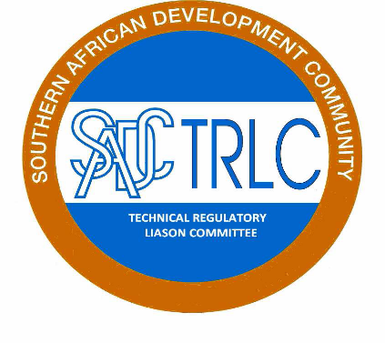

**DRAFT CONCEPT NOTE**

**______________________________________________________**

**IMPORTED USED MOTOR VEHICLES PROJECT**

**_____________________________________________________**

**CONCEPTUALISED BY SADC TRLC EXPERT WORKING GROUP,**

**February, 2016**

1. **BACKGROUND**

SADCTRLC recently completed a study on identification of technical regulations hindering trade in the SADC region. One of the proposed technical regulation is on the importation of second hand vehicles. The SADCTRLC is responsible for the harmonization of technical regulations and is now in the process towards harmonizing the technical regulation on “**Road Vehicles- Inspection and Testing for used motor vehicles for road worthiness”**.

SADC Member States imports over 40,000 used motor vehicles every year some of which have little service life because they are older models and spare parts cannot be found. The buyers end up parking these vehicles and eventually sell the scrap metal to the scrap metal dealers for recycling. Other parts of the motor vehicles like electronic components which cannot be recycled end up into our environment thereby increasing the environmental degradation.

In an effort to enhance road safety in the SADC Region, Member States issued various statutory instruments to compel the road worthiness inspection to be carried out before the used motor vehicles are shipped and/ or registered in respective member states. The Statutory instruments have various limitation in different member states.

For some years to come, some Member States will continue to import used motor vehicles. This will mean SADC Region will have serious environmental problems as most cars will be imported to replace those that have saved for only one or two years . Also as long as more used motor vehicles are imported to replace those that can no longer service the region, more foreign exchange will leave the region to buy replacement motor vehicles

In view of the above, SADCTRLC invited Botswana, Swaziland and Zambia Expert Working Group members to formulate a concept note and work programme for harmonization of the Standard on Road Vehicles- Inspection and Testing for used motor vehicles for road worthiness.

1. **JUSTIFICATION**

Reducing the safety, environment, and health risk associated with imported used motor vehicles.

1. **OBJECTIVE**
2. To enhance roadworthiness of used motor vehicles.
3. To reduce negative impact on our environment and health.
4. **METHODOLOGY**

**SADCTRLC Exco** will circulate the Draft Concept Note on imported used motor Vehicle Project to Member States for consultations on the proposed harmonization of the Standard on Road Vehicles- Inspection and Testing for used motor vehicles for road worthiness. Thereafter, Submission of Concept Note of imported used motor Vehicle Project to **SADCSTAN** for harmonization of the Standard on Road Vehicles- Inspection and Testing for used motor vehicles for road worthiness.

**5.0 RECOMMENDATION**

We wish to recommend that Member States consider the harmonization of technical regulation for Imported used motor vehicles to achieve the following benefits:

1. improved quality of used motor vehicles being imported into SADC Region thereby complying with standards;
2. Reduced air and environmental pollution ;
3. Reduced dumping of un serviceable vehicles;
4. Ensure that only vehicles that have available spare parts will be imported;
5. Reduction in the road traffic accidents;
6. increased safety as the latest vehicles are fitted with safety belts; and
7. The motor vehicles that use leaded and environmental polluting fuels will not be allowed to be imported.

**6.0 CONCLUSION**

It is necessary that SADC Member States implement measures to promote road safety. There has been many accidents associated with imported used motor vehicles that are not road worthy.

#### 7.0 IMPLEMENTATION PLAN.

|  |  |  |  |
| --- | --- | --- | --- |
|  | **Activity** | **Timing** | **Responsible** |
| **1** | Submission of the Draft Concept Note on the imported used Vehicle Project to SADC TRLC Exco | 4th February, 2016 | Zambia /SADC TLC Expert Working Group |
| **2** | Circulation of the Draft Concept Note on the imported used Vehicle Project to Member States for consultations | 8th to 24th February, 2016 | SADC TRLC Exco |
| **3** | Consolidation of Comments on the Concept Note of imported used Hand Vehicle Project from Member States | 3rd to 4th March, 2016 (South Africa) | Zambia /SADC TRLC Expert Working Group |
| **4** | Submission of Concept Note of Imported used Vehicle Project to SADCSTAN for harmonization of the Standard on Road Vehicles- Inspection and Testing for used motor vehicles for road worthiness | 13th March, 2016 | SADC TRLC Exco |